CONDITION-ACTION DECOMPOSITION (CAD)

|  |  |
| --- | --- |
| Condition | Action |
| N % 2 == 0, TRUE | PRINT “not odd” |
| N % 2 == 0, FALSE | PRINT “odd” |

CURSORY SCKETCHES (CS)

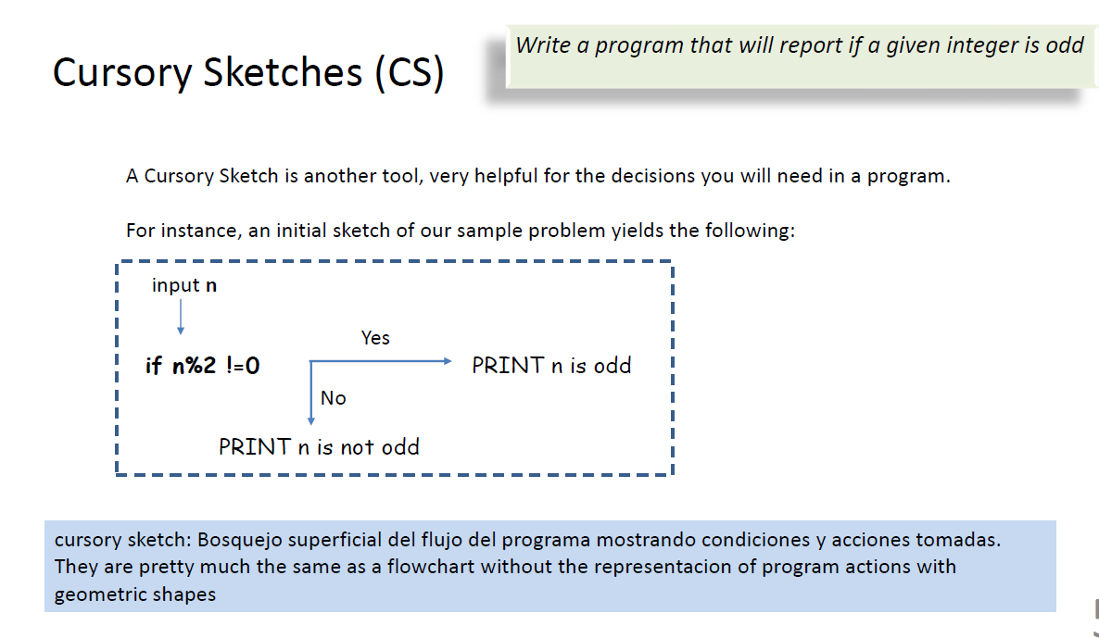

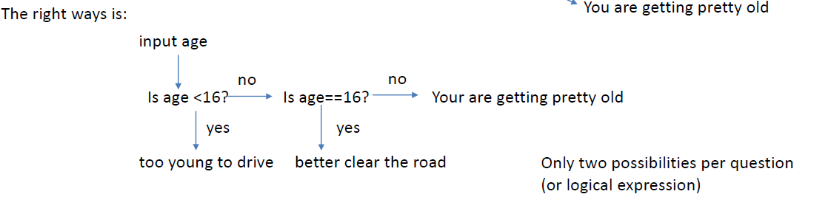

Example 2

|  |  |
| --- | --- |
| Condition | Action |
| Temp < 45, TRUE | PRINT “Bring a heavy jacket” |
| 45 <= Temp AND TEMP <= 75, TRUE | PRINT “Bring a light jacket” |
| 75 < Temp, TRUE | PRINT “Do not bring a jacket” |

Example 25

|  |  |
| --- | --- |
| Condition | Action |
| age < 13, TRUE | G |
| 13 <= age AND age < 16, TRUE | G, PG |
| age < 16 AND withParent, TRUE | G, PG, R |
| 16 < age | G, PG, R |

|  |  |  |
| --- | --- | --- |
| Input | Processing | Output |
| Age (age)  Is with parent (withParent)  Is student (isStudent)  Money (money)  Weekday (weekday) |  | Ratings (ratings)  Price (price) |